CYBER SHUJAA CLOUD & NETWORK SECURITY FINAL EXAMINATION
PACKET TRACER PRACTICAL
TIME ALLOCATED: 2 HOURS
TOTAL: 40 MARKS

Instructions:
- Answer ALL questions
- Submit your write-up/report as you have been doing in weekly assignments.
- Use this file as your write-up reporting template as you complete each task outlined and answer the questions.
- Rename this file (.docx) and your packet tracer file (.pka) with your full names.
- Once you have completed your work, save the file and upload it together with your final Packet Tracer file (.pka) for marking.
- Before leaving the exam, ensure you have uploaded the two correct files capturing all the work you have submitted for marking.
- Use this document to compile a detailed write-up that outlines your approach to addressing the various exam challenges. Ensure that your write up is authentic. Show screenshots of the working for all answers showing how you got your answers.
- Any answers without supporting screenshots will not be graded.
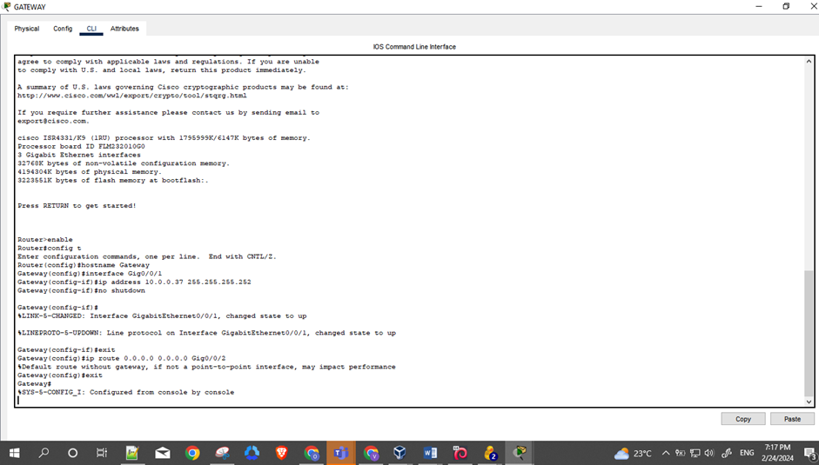
- The screenshots should capture your full screen and display the command you ran to get the answer. Include a taskbar showing your machine taskbar and time stamp. Here’s a sample.

Device | Interface | IP Address | Subnet Mask
R1 | G0/0/0 | 192.168.10.1 | 255.255.255.0
 | G0/0/1 | 192.168.20.1 | 255.255.255.0
Procurement Switch | VLAN 10
Sales Switch | VLAN 20
Mike’s PC | NIC | DHCP | ------
Jenn’s PC | NIC | DHCP | ------
Task 1: Configure VLANs and access ports on the Switches (6mks)
- Create VLAN 10 and name it Procurement on the Procurement switch and assign Fa0/2 to VLAN 10 (2mks)
- Create VLAN 20 and name it Sales on the Sales switch and assign Fa0/2 to VLAN 20 (2mks)
- Configure trunking on BOTH switches on Fa0/1. (2mks)
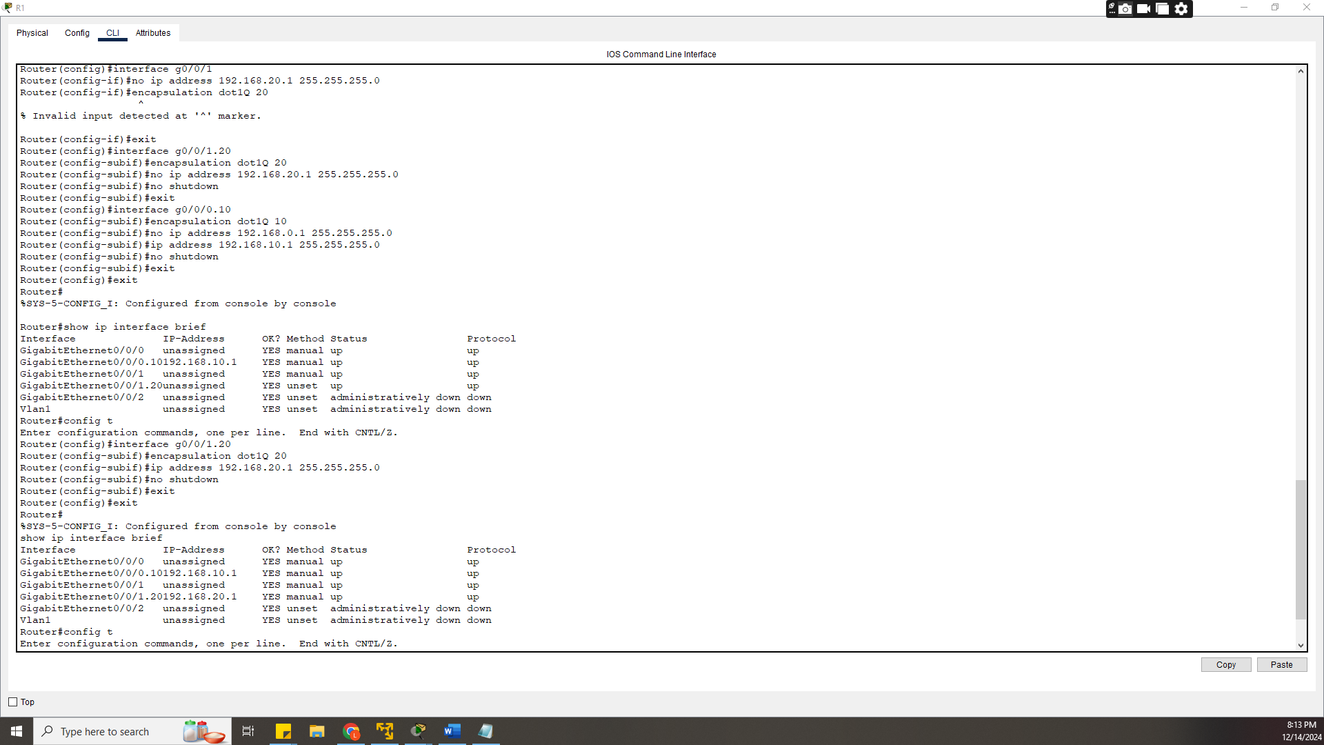Task 2: Configure Inter-VLAN Routing on Router (8mks)
HINT: Use interfaces g0/0/0.10 and g0/0/1.20 and use encapsulation dot 1Q <VLAN ID> for each vlan. This will specify the subinterfaces used for the VLAN traffic. The number after the decimal specifies the VLAN being configured.
- Configure gig0/0/0 with the information provided in the table above. (3mks)
- Configure gig0/0/1 with the information provided in the table above. (3mks)
- 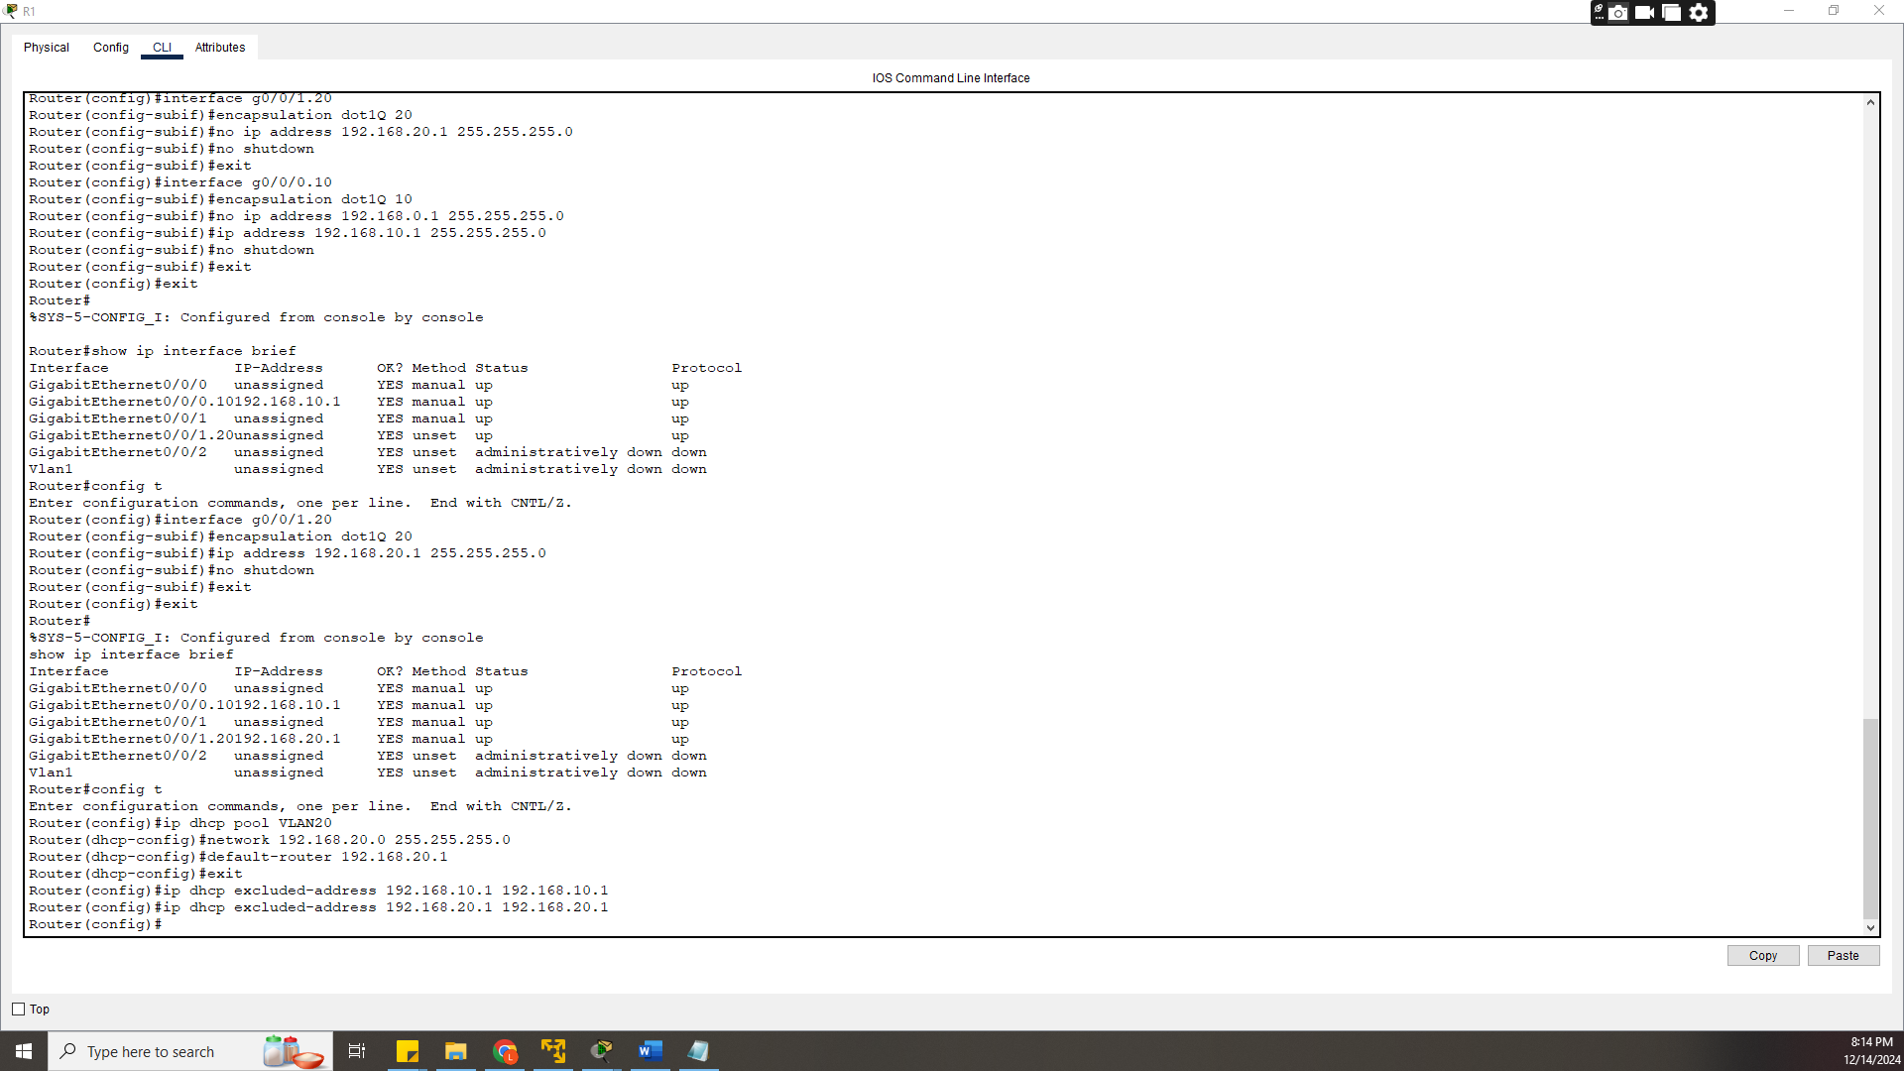Make sure both interfaces are up and running. (2mks)
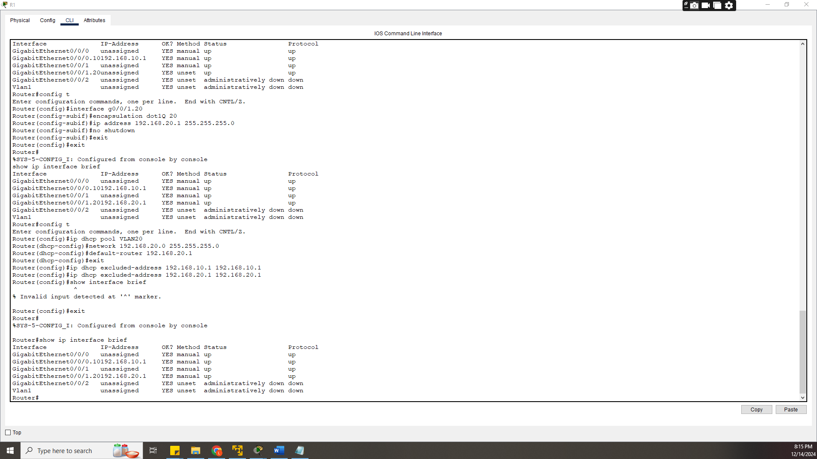
Task 3: Configure DHCP on the Router (8mks)
- Set up DHCP pool called VLAN10 (3mks)
- Network pool = 192.168.10.0 255.255.255.0
- Default router = 192.168.10.1
- Set up DHCP pool called VLAN20 (3mks)
- Network pool= 192.168.20.0 255.255.255.0
- Default router = 192.168.20.1
- Exclude router IP addresses for g0/0/0 and g0/0/1 from the DHCP pools (2mks)
Task 4: Activate DHCP on PCs and verify connectivity (5mks)
- Activate DHCP on Mike’s PC. (1mk)
- 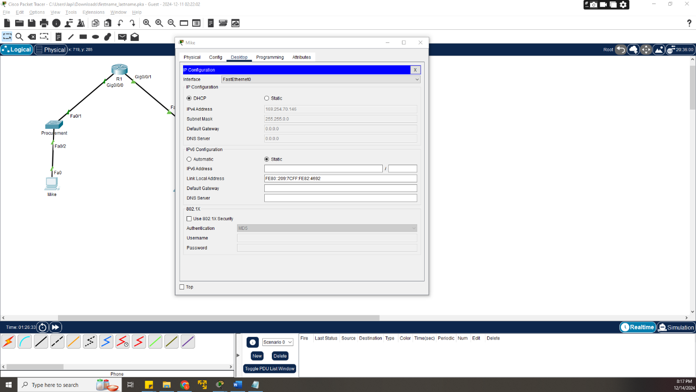Activate DHCP on Jenn’s PC. (1mk)
- 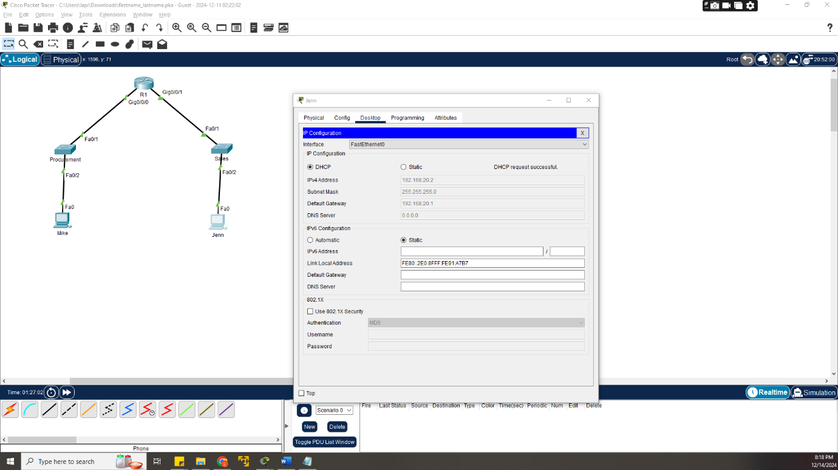Ping Jenn’s PC from Mike’s PC (1mk)
- 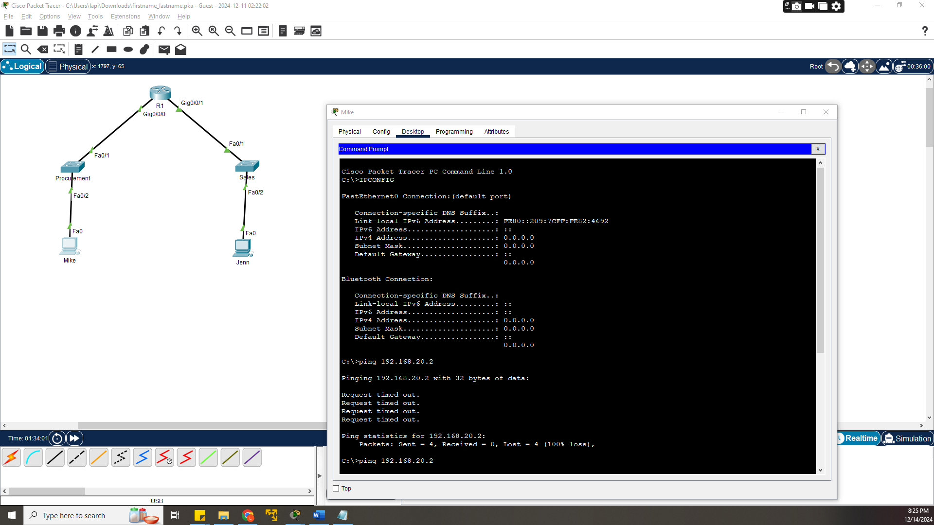Ping G0/0/1 from Mike’s PC. (1mk)
- 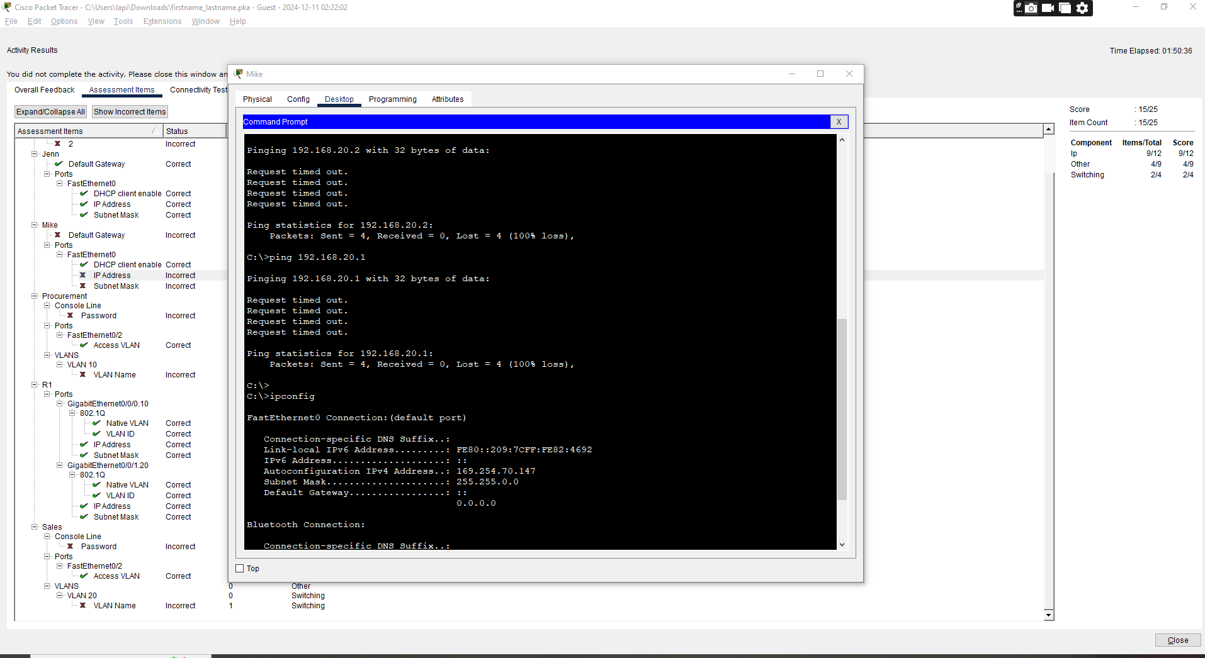Ping G0/0/0 from Jenn’s PC. (1mk)
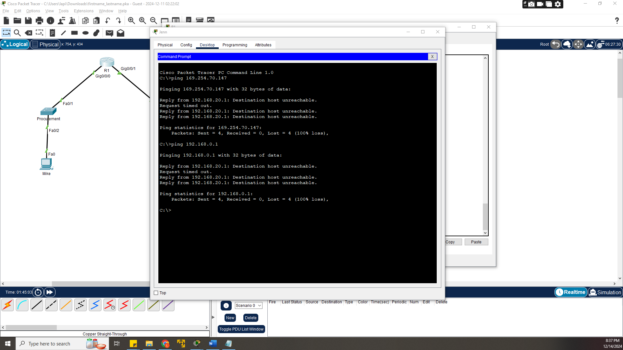Task 5: Configure Switch Security on BOTH switches (4mks)
- Enable line console password “Shujaa254” on the Procurement switch (2mks)
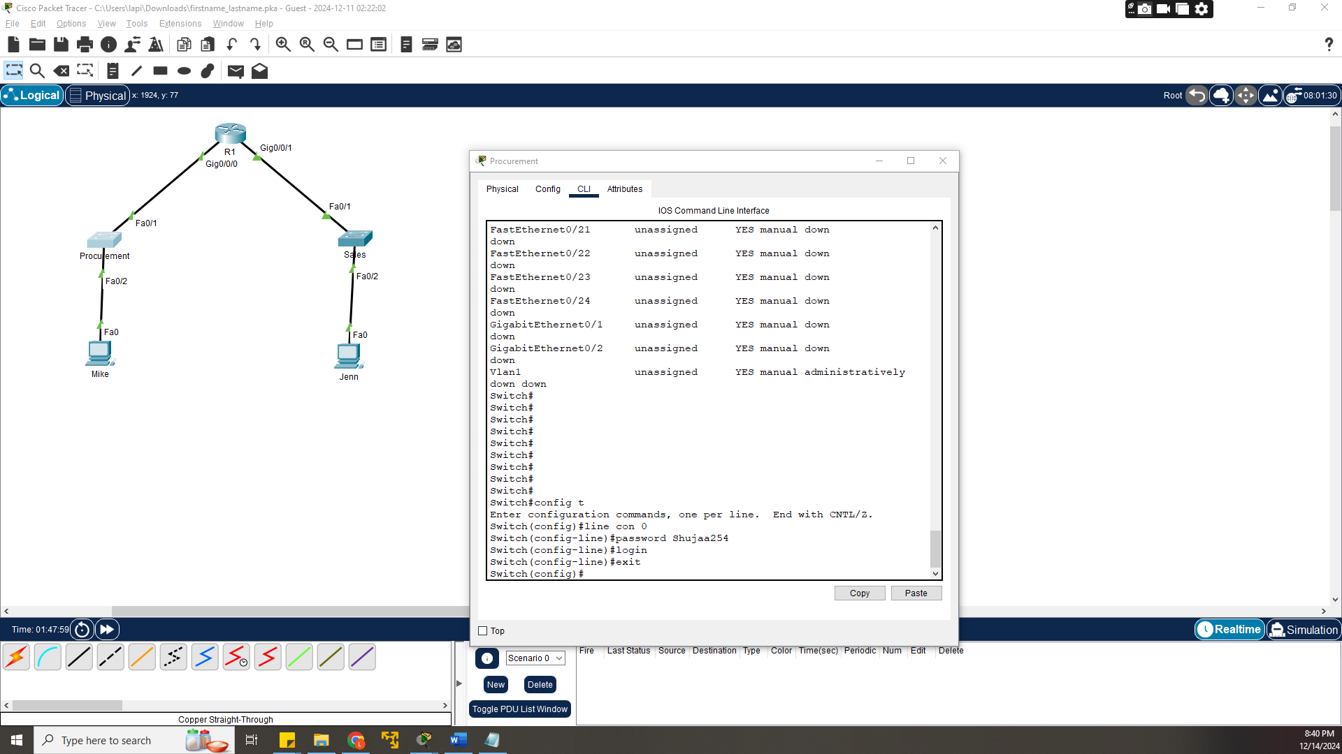
- Enable line console password “Shujaa254” on the Sales switch (2mks)
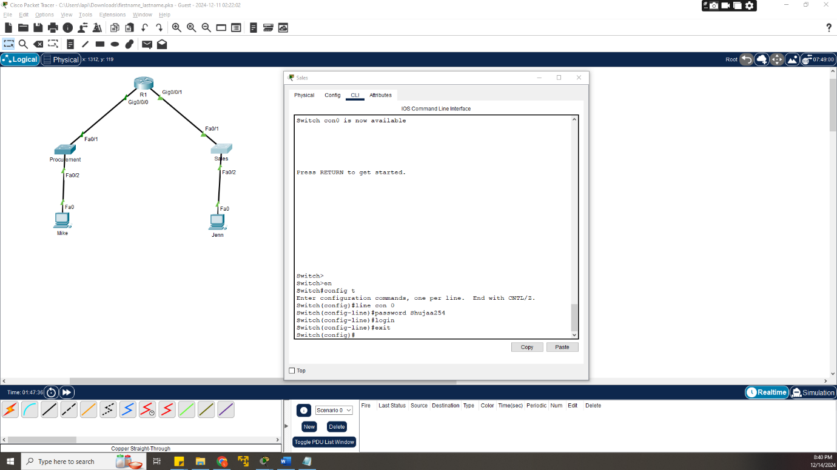Task 6: Implement BPDU guard (9mks)
- Enable BPDU guard on the Procurement Switch for port Fa0/2. (2mks)
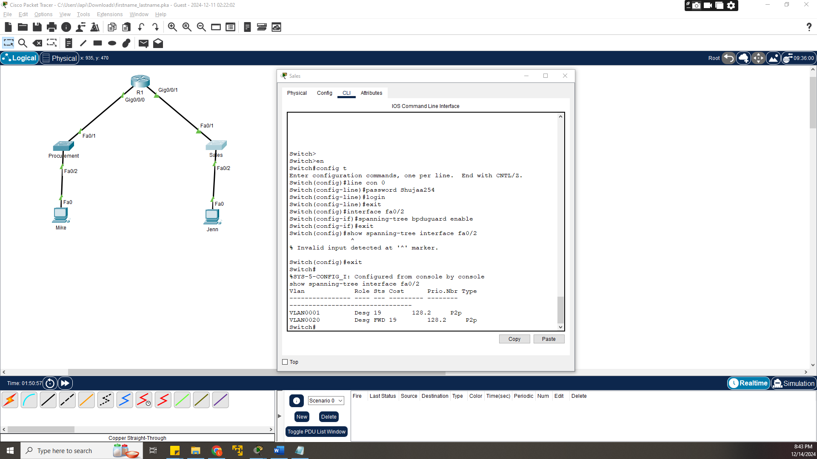
- Enable BPDU guard on the Sales Switch for port Fa0/2. (2mks)
- 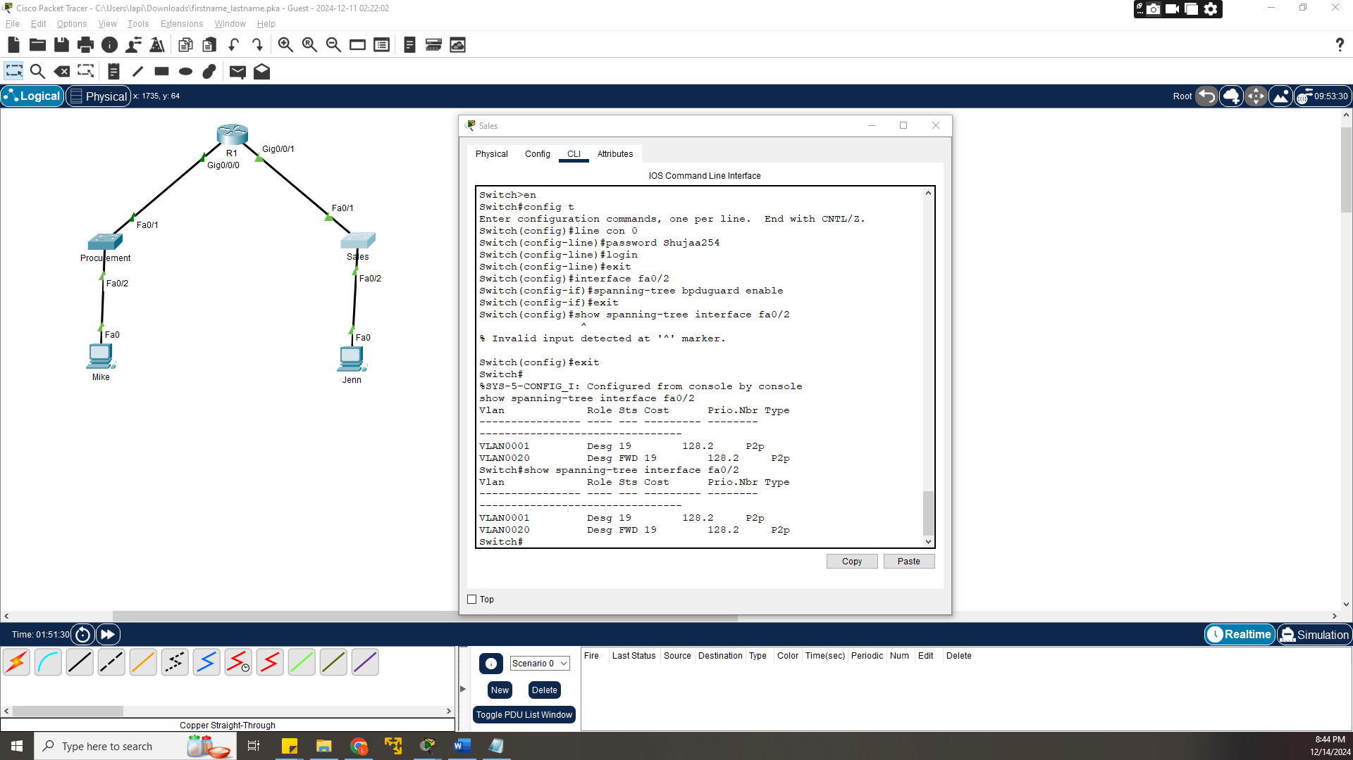Verify BPDU is enabled on the appropriate ports. (2mks)

